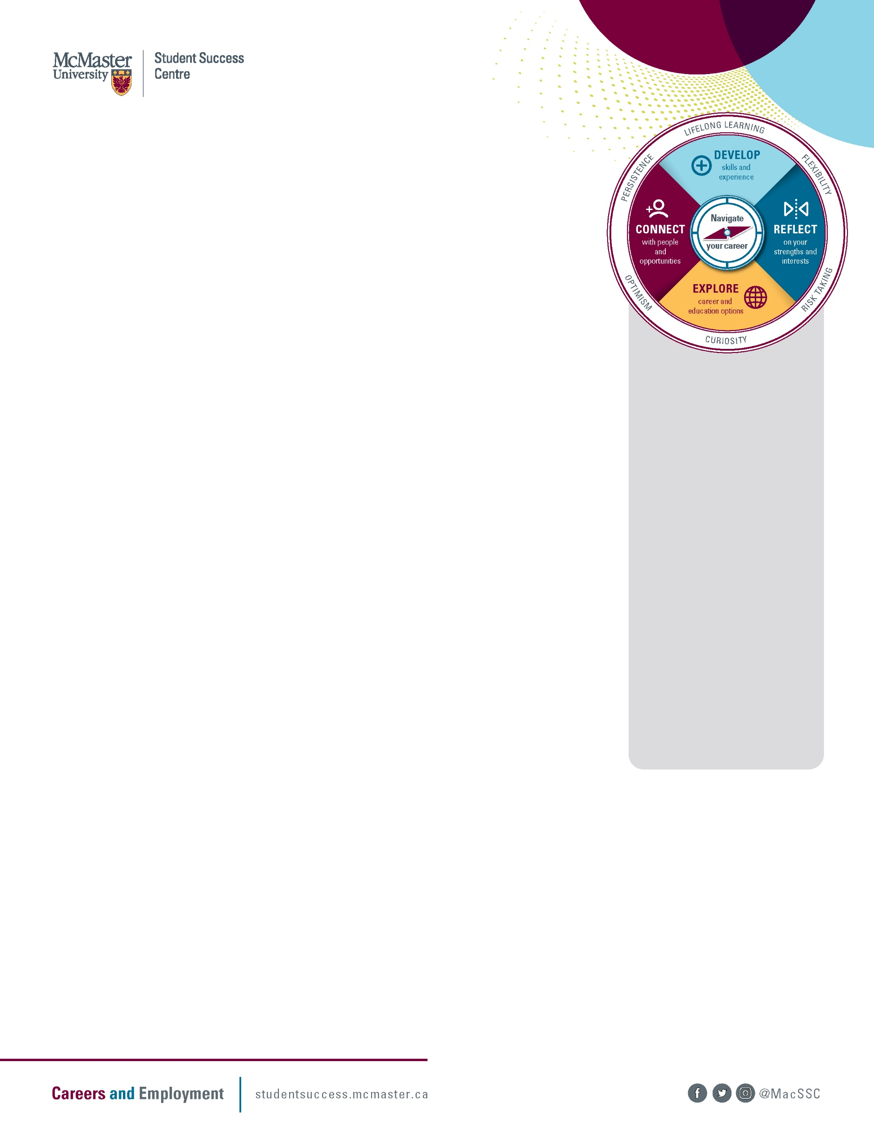

Pondering My Life
Use your curiosity to reflect and discover.

Activity overview:
Curiosity is essential to help you successfully navigate your career. Pondering over the guided questions in this activity can help you gain insights about yourself. You might notice some aspects of yourself you forgot about or haven’t paid enough attention to lately. Also, you might reaffirm aspects that are clear for you and gain more confidence. And you might identify patterns and themes that can then help you navigate what’s next in your career path.
According to Dr. R. Vance Peavy, one of the most influential contributors to the counselling profession, questions have much greater power than answers. Questions lead to new alternatives and explorations, but answers make it easier to ignore other options.

Instructions:
Have fun pondering these questions, either through quiet reflection, discussion with a peer or writing down your thoughts. Give yourself time to reflect and pay attention to what matters to you.
Start by scanning the questions and answering the ones you’re most interested in. Then, work through the other questions as you feel inspired. Some of the questions might be harder to respond to. That’s okay! Just give yourself some time to reflect — try not to force it, and feel free to skip questions (but not too many).
Enjoy!

Activity length
10–40 minutes

Enjoy the open exploration and try not to force any conclusions. Let your curiosity about yourself be enough.

Tips

Brief overview

Answer open-ended questions to help you gain insights and discover patterns.

Think about it
If you were 10 times braver than you are now, what would you be doing differently?

In the past weeks or months, what experience(s) did you find most draining? Describe the situation(s). What aspects drained your energy?

In the past weeks or months, what experience(s) made you feel the most energetic and enthusiastic? Describe the situation(s).

Consider an accomplishment you’re proud of. It doesn’t have to be something big. What skills or characteristics did you use to make it happen?

What types of people bring out the best in you? What characteristics do they bring out? Where do you find these people in your life?

What are some tasks you haven’t done yet that you think you’d be good at?

What is your favourite quote, motto or saying?

- How does your favourite quote, motto or saying relate to your current concerns or questions about your future? What message is it giving you?

Name three people you admire. Why do you admire them?

Complete this sentence.
Success to me means…

Think about past tasks or projects you enjoyed. What talents, abilities or characteristics do you notice most in yourself? Are there clues from your childhood that reveal these talents?

What skills or abilities do you have now that you didn’t have a year ago? Three years ago? How did you develop these skills or abilities?

Imagine and visualize
If you could create your ideal work week, what would it be? What tasks are you doing? What strengths are you using? Who are you with? What is the work environment like? What kind of impact are you making? What problems are you solving?
Don’t worry about an actual job title, just consider the elements that would be great for you.

Now what?
After reflecting on these questions, what insights emerged for you? Were there any trends or themes? What ideas or thoughts would you like to explore further?

